Yohan scuiller 19/06/14

♥ My Trip To L'Aber Wrac'h ♥

On Friday morning, it was sunny, we went sailing with Tristan and Nathan. I had a great time!!!!
A Lunchtime at 12:30, we had rice and stuffed tomatoes. Yuck!!!!!!!!!!!!!!!!!!!! 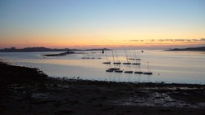
In the afternoon ,it was sunny and cloudy, we went sailing with Tristan and Nathan. It was fantastic !!! We had a snack at 4.30 pm. and we left L'Aber Wrac'h.

